Chapter 1

Motivation

The subject I am going to cover is the phenomenon of Open Source, or to be more precise Open Source Software (OSS) development. In software development there are basically two different forms or organizations: The Commercial or Closed Source Software (CSS) developers who are organized in a company aiming at profit (e.g Microsoft), and the Open Source Software developers who operate voluntarily in an online community. The first time I got in contact with Open Source development was during the bachelor thesis ‘E-organizations in the digital economy’, by writing a research paper on online communities. I found it fascinating that geographically distributed individuals who work voluntarily on software development can create significant results. Some CSS developers saw this OSS movement as a direct thread for their business.

An interesting paper by Paulsen et al (2004) created a link between Open and closed source on the one side and creativity on the other side. They claimed creativity was more prevalent in OSS than in CSS, which I found a very interesting conclusion. Yet reasons why this creativity was higher in OSS were not mentioned. This was the direct cause for me to dig deeper in the concepts of OSS and creativity and eventually write this thesis.

Before focussing in on the problem definition I will first elaborate on the fields of Open Source and Creativity.

Problem Field

Kneller (1965) formulated creativity as the process of re-arranging what we know in order to find out what we do not know. The definition I will use and that the more traditional literature on creativity in an organization uses describes creativity as “the production of novel and useful ideas in a certain domain” (Woodman et al, 1993;). Innovation is seen as the succesful implementation of these creative ideas (Amabile et al, 1996).

Incremental / radical.
Tushman/Anderson: Era of ferment/incremental: 1st battle for dominant design and than development of the dominant design.

Henderson/Clarck: Architectural innovation; radical and incremental.

Open source software (OSS) represents a private-collective model of innovation where developers obtain private rewards from writing code for their own use, sharing their code and collectively contributing to the development and improvement of software (von Hippel and von Krogh, 2003).

The open source software "movement" has received enormous attention in the last several years. It is often characterized as a fundamentally new way to develop software that could pose a serious challenge to the commercial software businesses that dominate most software markets today. The challenge is not the sort posed by a new competitor that operates according to the same rules but threatens to do it faster, better, cheaper. The OSS challenge is often described as much more fundamental, and goes to the basic motivations, economics, market structure, and philosophy of the institutions that develop, market, and use software.
Basic arrangements to ensure freely available source code have led to a development process that is radically different, according to OSS proponents, from the usual, industrial style of development. The main differences usually mentioned are (Mockus et al, 2000):
- OSS systems are built by potentially large numbers (i.e., hundreds or even thousands) of volunteers.
- Work is not assigned; people undertake the work they choose to undertake.
- There is no explicit system-level design, or even detailed design.
- There is no project plan, schedule, or list of deliverables.
- These differences suggest an extreme case of geographically distributed development, where developers work in arbitrary locations, rarely or never meet face to face, and coordinate their activity almost exclusively by means of email and bulletin boards. The difference with for example ‘the virtual organization’ as discussed in e.g. Chesbrough and Teece (2003) is that open source movements consist of volunteers, is open for everybody to join and do not aim at developing a commercially interesting product or making profit.

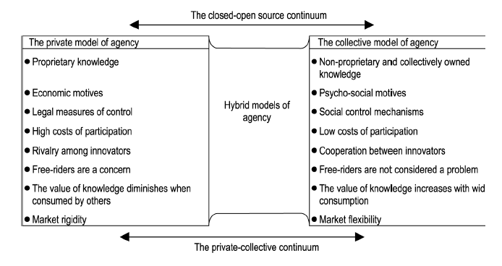
The figure posted below gives an overview of the differences between the open and closed source models.
Figure 1 Ulhoi 2004

What is perhaps most surprising about the open source process is that it lacks many of the traditional mechanisms used to coordinate software development, such as plans, system-level design, schedules, and defined processes. Disadvantages can be lack of coordination and structure, whereas commercial development typically uses a number of coordination mechanisms to fit the work of each individual into the project as a whole (Herbsleb and Grinter, 1999).

On the other hand OSS have proved to be able to deliver good results, sometimes even superior to commercial products. It is claimed, for example, that defects are found and fixed very quickly because there are “many eyeballs” looking for the problems (“Linus’s Law”). Code is written with more care and creativity, because developers are working only on things for which they have a real passion (Raymond, 1999).

Creativity!!

Inzoomen probleemstelling

In the past their have been several studies that have covered open and closed source projects and the level of creativity (Mockus et al, 2000; Paulsen et al, 2004). Creativity in the Mockus et al study was measured as ‘the time to resolve problem reports’. The standard in which Paulsen et al measure creativity is ‘the number of functions added over time’ to a software project.

In the case study on the development of the ‘Apache Server’ Mockus et al. found that the open source project foster more creativity than a comparable closed project on the organization and team level. This result is later confirmed by Paulsen et al. In their research they compared three successful open source projects with three successful closed source projects.

 | Mockus et al (2000) | Paulsen et al (2004)
Research method | Two case studies; the Apache server and Mozilla. | Emperical study of three open-source and three closed-source projects.
Summary | By using email archives of source code change history and problem reports aspects of developer participation, core team size, code ownership, productivity, defect density, and problem resolution interval for the OSS projects are quantified. | Comparison is made between open and closed-source projects on the aspects of system growth, creativity, modularity, defects and simplicity. Only a significant result is found for the aspects creativity and defects.
Hypothesis |  | Open source projects foster more creativity.
Creativity measured by | Time to resolve problem reports | Number of new functions added over time
Conclusion | OSS developments exhibit very rapid responses to customer problems. | Hypothesis on creativity supported; The number of functions added was greater in the open source projects than in the closed source projects.

The contribution of my research lies in filling in the gap in the open-source literature, by trying to explain why creativity is more prevalent in open source than in closed source environments. Therefore I will first provide an overview of relevant literature on creativity, especially on the organizational level.

Research question:
Why is creativity higher in open source innovation than in “closed” innovation?

Deelvragen:

  - What effect do organizational factors / context have on creativity?
  - What are the differences in organizational factors / context between Open source and Closed source (software) development?

Methodology

Current ideas:

- Pick out one or multiple, preferable Dutch online OSS communities and one or multiple CSS environments. The open and closed environments have to operate in a comparable field, for example gaming software, database development or some sort of specific application software.

- Contact community/business leaders for interviews and information sharing.

- If possible do own observations of the environments.

 | Closed Source Software | Open Source Software
Radical Innovation

Incremental Innovation

This figure links the ideas of incremental and radical innovation with the ideas of open and closed source software development environments. This link has not yet been made in current literature and it could help me find an answer to my research question. It will be interesting to see what kind of innovation takes place in which environment.

From my own reasoning the OSS innovation is more likely to involve incremental innovation.
Here you have a ‘dominant design’ or in this case a source code, where the ‘many eyeballs’ can be effective in finding and fixing problems or adding incremental functions the the code. That leaves the radical innovation in the software industry likely to be performed mainly in the CSS environment.

