Pre Summer Party 2004
Already number 6 in a series of blasting events!
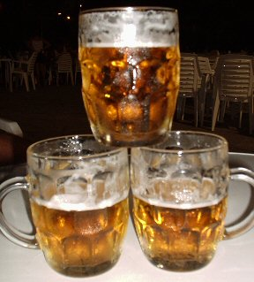
Date: Sunday the 30th of May
Location: Dorpsstraat 2 – Woensdrecht (Holland)
Entrance: € 7,50 (but free if you are naked, except for Kuijlen)
Reason: Dammert’s birthday ofcourse you idiots!

What the hell is new this time?!

Ofcourse we have a special surprise for you in petto and this time it’s provided by our very own: Knokboer Bones™ ! At midnight sharp you will witness a spectaculair fight for the title of Knokboer n° 1! The tension between these two champions is high as previous fights have been cancelled! (Illegal betting on this fight is allowed)
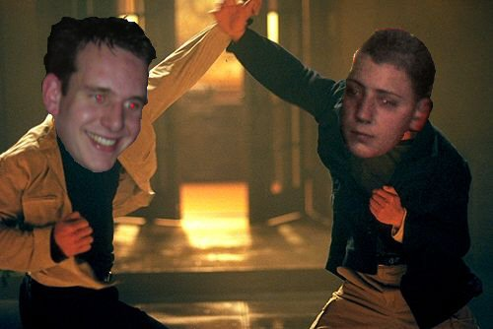
As
Always
The
Music
Is
In
The
Hands
Of
Our
Professional
DJ-Team! ☺

What else is there?!

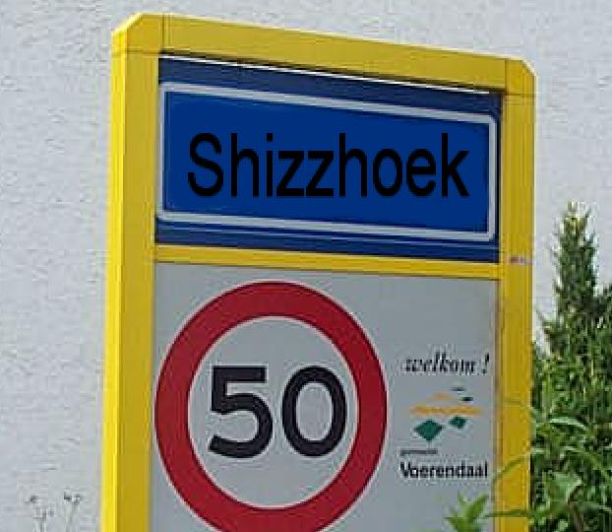
Because of last-years succes, again we’ll have Clio’s pending to the after-party @ Shizzhoek!

This is all in the safe hands of Mr. Hessels. Below a picture of last years trip.. Oeps!

Warning! The Clio-service is starting around 5:00u!!

Also according to the tradition we need to break the old Jupiler drinking record, last time there where 264 bottles ‘arrested’ so you’d better be thirsty this time!! Hope 2 see you all! Grtz!
Information or reservations: 06-54622117
Entrance from: 20h (unless you want to help build up :P )
)

All rights reserved by Dammert Productions® in corporation with ED&T™

